

GUILDWARS 2 Dragons Stand Meta Mid Lane Guide

Things you need to know about the Mid Lane of Dragon Stands Meta.

By Nersyss AKAMarta

Guradian of the united[gotu] & Exodus/z of the elder dragons/z[GODS]    EU based

**Mid Lane xx:30**

**IMPORTANT**

* **MID** **-** **Legendary Blademaster Diamid:** spins, splits into 3.
* **Do not CC the Mouth of Mordremoth.** If as minimal CC as possible you can 1 Shot the boss with high DPS

**EVENTS x3**

**- Retrieve engine parts to keep the cannons online:** You have to gather engine parts and bring them to the NPC. You can use little udrafts to get to the upper level. Be careful with the AoE circles, they will stun and damage you.

**- Help Grumlukl create his bombs:** You have to escort the Itzel and defeat the mobs.

**- Defeat the mushrooms to rescue the trapped Itzel:** Poison Mastery needed. You have to defeat some mushrooms, and then a Mushroom King will appear. You can start the event by talking to Muldotl, he’s right where the event takes place, a bit away from the Camp.

*This is the only time there will be three events at the same time. You can ask some ppl to stay and do the collect event (engine parts). Then you go with the rest to the other 2 events. First you can do the escort, you have to start it by talking to Grumlukl (he’s close to the camp on the right). After this event you can go to the other (mushrooms), since it takes place near the end of the escort. For this one poison mastery is needed.*

**ESCORT**

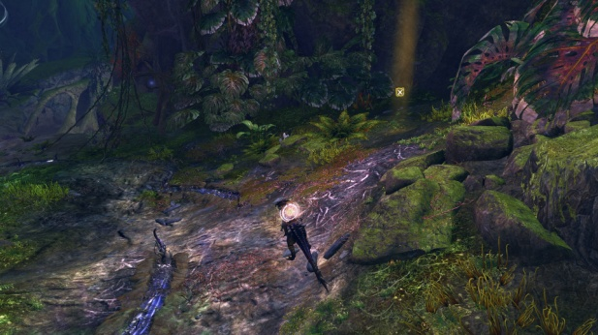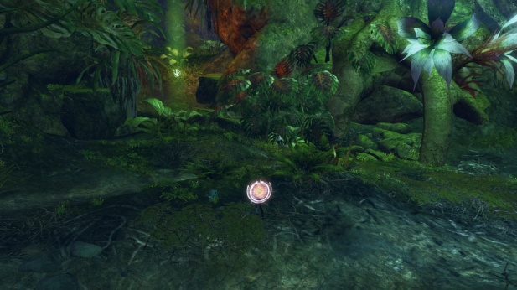First you will find the Thornheart, it spawns at the beginning of a little path on the left, the same path the escort event used. The stalkers will spawn on the right of the path, a bit after the Thornheart.

**SPITFIRE & VINETENDERS**

Here you have to focus on the Wurm Boss and DPS it as soon as the shield disappears. Some Vinetenders will spawn around it, you have to kill them or else they will put the shield on the boss again. They are protected by some mobs.

**EVENTS x2**

**- Toss salvaged scraps to Overseer Braeden so that he can build barricades:** You have to gather salvaged scraps and bring them to the NPC. Be careful with the mobs.

**- Destroy the Mordrem prisons and get the soldiers to their chopper (5 soldiers):** Poison Mastery is needed. You have to rescue 5 NPCs trapped in prisons. Once they are free escort them to the chopper, and be careful with the mobs, they can kill the NPCs (you can revive them).

*For these events it’s better if the squad follow he commander to the prisons event and a little group takes care of collecting scraps.*

**ESCORT**

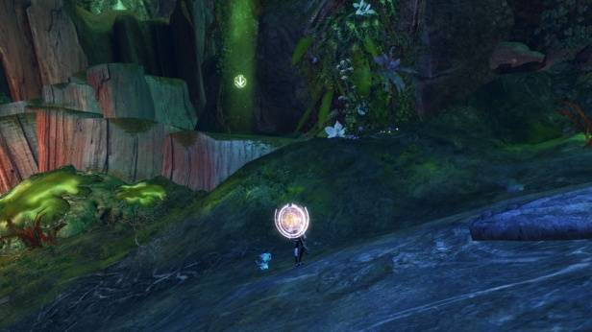This time when the Thornheart spawns the Legendary Blademaster Diamid is quite close. Diamid goes at its own peace, but if players engage it gets to the escort even faster. The Thornheart can slow down the escort; for this reason it’s better to focus on it first, and then go to the Diamid. It’s quite normal that some players engage the boss, so you will have them both at the same time. Try to focus the Thornheart. The stalkers also spawn near there, so sometimes you fight them at the same time as the Legendary Boss.

*The Thornheart spawn on the left of the path (arrow marker).*

**SPITFIRE & PRESERVERS**

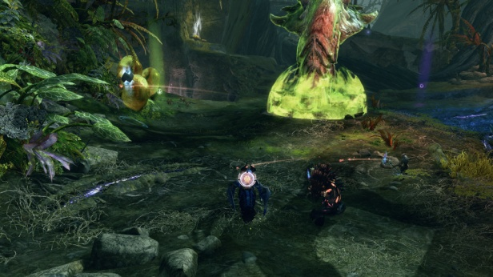 After the escort you will face another Spitfire. This time before the boss you have to kill the preservers, which will spawn near it. If they reach the Wurm they will restore its health, so kill them fast. The first one spawns on the left (*arrow mark*), and the second one on the right (*circle mark*). After defeating them use full DPS on the Wurm Boss.

If you want to try, there’s another option, to kill the Wurm Boss before the preservers reach it, but you need to have a lot of DPS!

**EVENTS x2**

**- Climb up and retrieve the flamethrower supplies:** You have to gather flamethrowers and bring them to the NC. You can use bouncing mushrooms and ley line energy. Be careful with the Legendary Wyvern, some of the supplies are on its platform.

**- Defend Alara the Wolf as she builds turrets:** You have to escort Alara while she builds turrets. On the way there and while she’s building each turret some mobs will spawn.

*For these events you can divide as you want, depending if you want to kill the Legendary Wyvern. An option to get to the tower fast is to send a little group to the collect event and the rest follow the commander to the escort event. This way, when the escort ends you can stay near the tower to kill the Legendary Boss, while the other group can stay with the final escort.*

**ESCORT**

After the escort event and before the final escort you can go to the tower’s gate and wait for the Legendary Boss. Some people will have to stay with the escort since some stalkers will spawn.

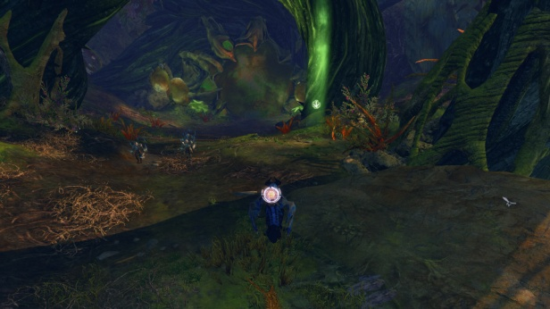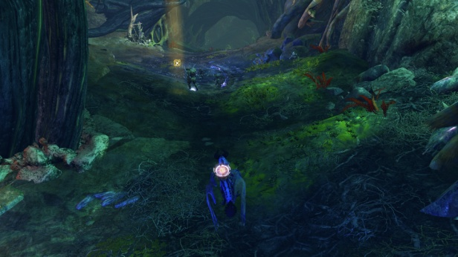During the escort first you will face the stalkers; they spawn right at the path the escort follows. After defeating them and a bit closer to the tower, the Thornheart will spawn on the right.

**TOWER**

When all the lanes reach the gates the next phase starts. Here you will enter a circular room with a platform in the middle where there is one of the Legendary Bosses. Around the platform 3 Ley Line Pods will spawn; the boss will be invulnerable till you destroy them. Those collectors are protected by 3 preservers that can restore them or even respawn them.

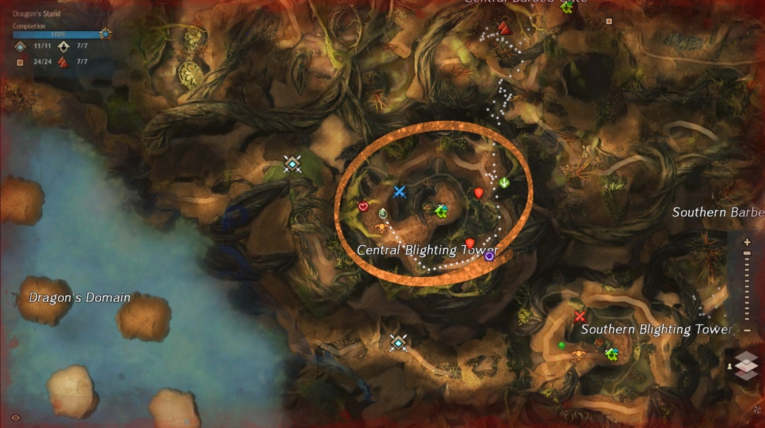You will need two groups; a little group of around 10 players will go to the middle and kill the Boss, and the main one will follow the commander around the room destroying the collectors and the preservers. Even if the collectors are destroyed the preservers will keep spawning, so the group must keep running and killing them; use CC on them so it’s easier to do so. Full dead players should use the WP since it will be very difficult to revive them, and using swiftness really helps on this phase, a slow rotation can cause the collectors to spawn again. If the collectors respawn the Boss will be invulnerable again, or even revive if it was already killed.

*Shields/swords:* ***Collectors***

*Arrow, circle and heart marks:* ***Preservers’s*** *spawn location*

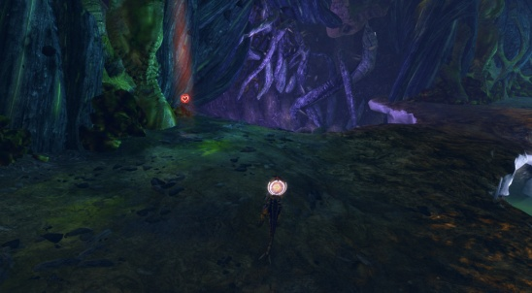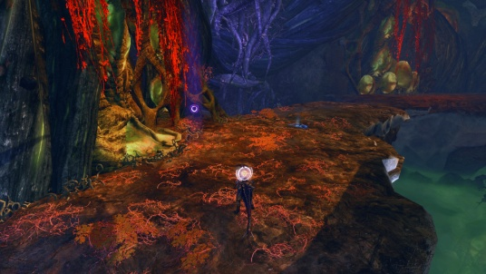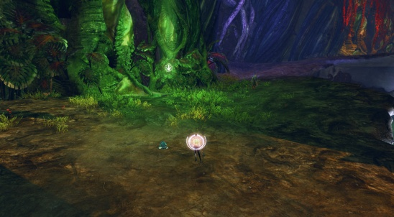

AFTER TOWERS:

**Against the Mouth of Mordremoth**

You will enter a large space of 9 islands, 3 for each lane. The players have to spread across them. The Updraft Mastery is required for this phase, and having Ley Line Gliding mastery makes everything a bit easier since the islands are connected by energy flows.

On this phase you will face different events. In different occasions the **Mouth of Mordremoth's** **head** will attack one island, and at the same time the **dragon’s** **body** will be near another island. Each squad has to go to the nearest. It’s a short attack and you have to be careful with their attacks. The head can do different attacks: fear players, drop bombs or smash the island (for this one look for when the heads goes quite above the island, you have to get off the island or it can instakill you). Some other events that can happen are:

* Destroy the ley-line disruption pods
* Destroy the vine growth: if the event fails a part of the island is destroyed
* Defeat the Mordrem Commanders: the three Legendary Bosses will spawn one on each island.

The important event on this phase is when the Mouth of Mordremoth's head attacks an island and at the same time bombs spawn on another one. The fightwill be longer and is the perfect chance to do as much damage as you can. On this part some bombs spawn on a random island; players near it have to go there and pick one to throw it to the head (don’t throw it when the blue bar is up). Bombs do most of the damage so it’s important to bring as many as possible; you can use the WP to move while holding a bomb. It’s really important not to use CC to have time for the bombs to get to the head.

**Squad chat**

*xx:25 🡪* Mount up until xx:30 so you don’t die. Also at xx:30 map will reset so join fast my instance to get a place into the map. Map will get full fast.

If we end up in a different map than the rest of the Commanders I will swap instances. If that’s the case I will tell.

*1 min left 🡪* Mount up to not die, or use a chair if you have one.

**EVENTS x3**

6-8 ppl stay here for collect event; if you don’t have poison mastery stay here. Rest come with me for escort.

Follow me, poison mastery needed.

**ESCORT**

Thornheart will spawn at arrow. Use your bunny. This boss will need a lot of CC at first.

Stalkers will spawn around X mark, kill them fast.

**SPITFIRE & VINETENDERS**

Full DPS the Wurm Boss when it is unshielded. Kill Vinetenders when they spawn, they put a shield on the wurm.

**EVENTS x2**

Around 6-8 ppl stay here to gather scraps. Rest with me to rescue prisoners, poison mastery needed.

**ESCORT**

First we do the Thornheart, and then we go to the boss, let it come to us.

Thornheart will spawn at arrow. Use your bunny. Remember to use heavy CC on it.

**SPITFIRE & PRESERVERS**

This time we kill preserver first, first arrow and then circle. Then full DPS the Wurm Boss. If the preservers reach the Wurm they will restore it, so we have to kill them fast.

Stalkers will spawn around X mark, kill them fast.

**EVENTS X2**

Some ppl stay here to collect flamethrowers. Rest with me to escort.

Let’s kill the boss before the escort. I need some ppl to go back and stay with the escort, call if you need help.

**ESCORT**

Thornheart will spawn at arrow. Use your bunny. Remember to use heavy CC on it.

**TOWER**

For the tower phase we need to kill some preservers (and collectors) and also kill the boss on the middle.

Some volunteers go to group 2 for the boss, max 10. Group 1 with me will rotate and kill preservers. Group 2 after you finish join us or help other lanes if needed.

Group 1: After we killed all collectors use CC for preservers and run fast to make sure they don't reach the zone. Run fast to the point that I mark, don’t wait for me and don’t resurrect fully dead players (use WP).

Group 2: Stack the boss to the middle; don’t let it come to us.

**MOUTH OF MORDREMOTH**

Crowd Control Skills (Cripple, Fear, Taunt, Knockback, Knockdown etc.) Please do not use these skills against Mouth Of Moredemoth. ALL Squads also get the BOMBS; throw them when there is no blue bar.